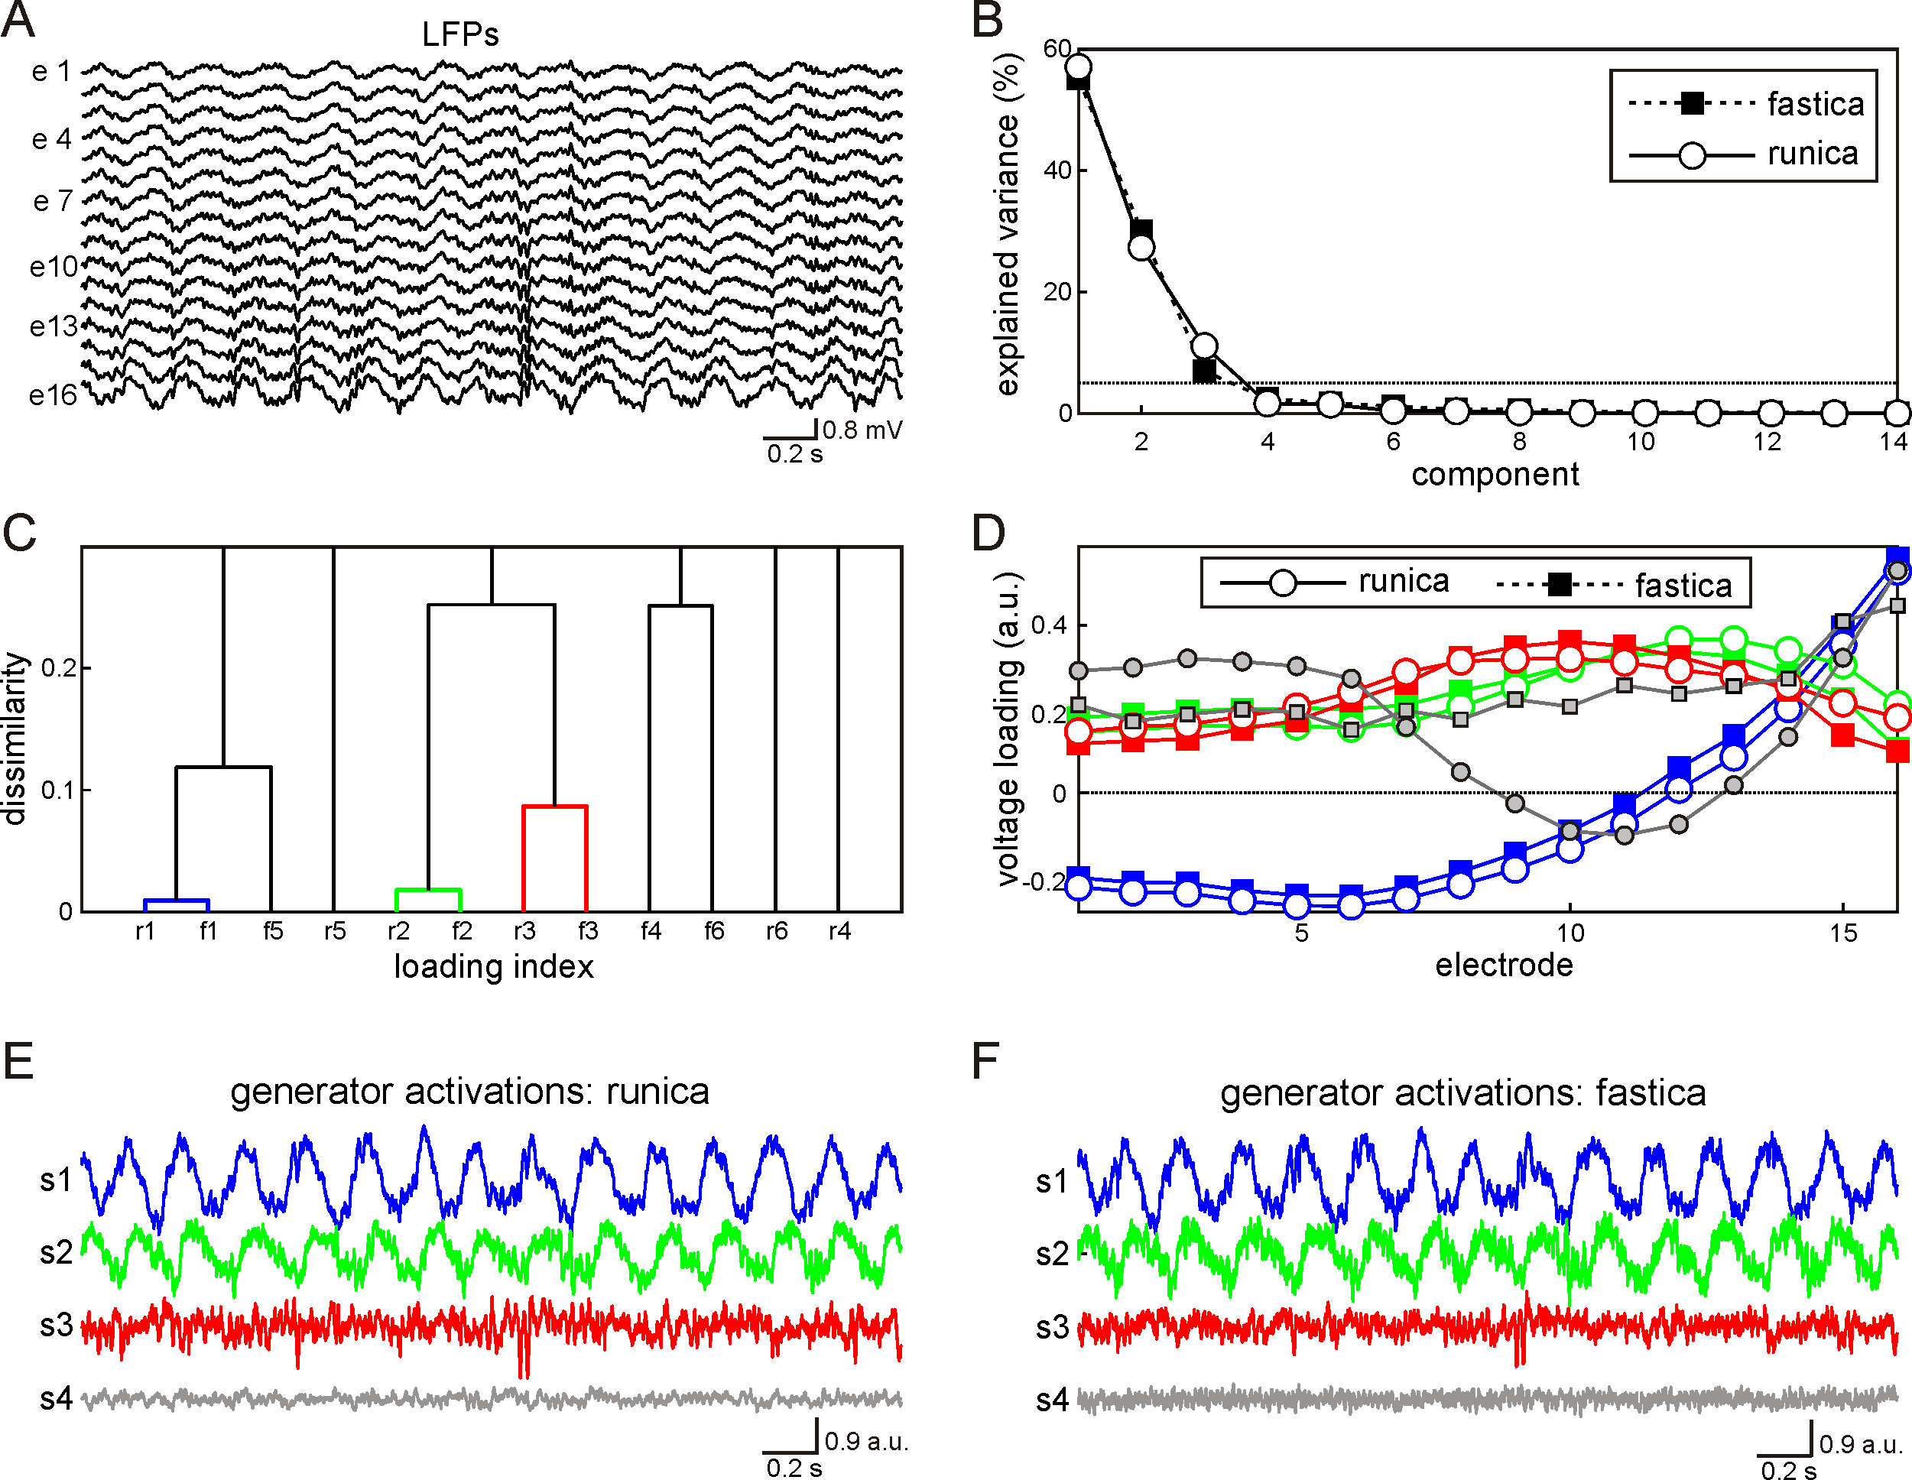
sFig. 2: Comparison of runica ("extended" option is switched on) and fastica algorithms. A) Raw LFPs. B) Back-projected component variances obtained for both algorithms. First three components are the strongest (each describing > 5% of variance, dashed horizontal line). C) Dissimilarity between spatial loadings [H₂ distance, Eq. (4) in the main text]. Letters "r" and "f" stand for runica and fastica, respectively, digits from 1 to 6 correspond to the number of independent components obtained by each algorithm (only the first 6 components are shown). The first three (most powerful) components provided by runica and fastica are similar, whereas the others show considerable differences. D) First four voltage loadings provided by runica and fastica algorithms. E,F) Activations of LFP generators G1-G4 found by runica and fastica.

